**Name: Wong Keng**

**Capstone 2 Project 2: FileExplorer**

**Filename:** *FileExplorer.java, comp.sh*

1. **Background:**

Trainer, Chandra, has provided us with the FileExplorer.java and comp.sh files which he had written. Chandra has only written the code for the application structure and the first menu item, “Directory Listing”, and also modified the zsh file, “comp.sh”, to be able to run in the Mac environment.

1. **Objective:**

To learn about the various Java I/O related APIs and the applications of some of the key   
I/O APIs.

1. **Requirements:**

We are required to do the following with the files:

1. Review the codes in both files to understand what they are supposed to do.
2. Ensure that the zsh file can compile and then run the java file in my Mac terminal  
   environment.
3. Write the codes for the remaining menu items the java file; namely
   * Create Directory
   * Create Directory Tree
   * Change Directory
   * Create File // Write to a File
   * Display File // Echo Contents of a File
   * Copy File
   * Rename File
   * Delete File
   * Delete Folder or Folders
4. Set up a simple test environment to test all the add functionalities listed in Point C.
5. **What I have done:**
6. I set up the file structure on my Mac.
7. I modified the zsh file, “comp.sh”, to work in my Mac environment.
8. I was able to successfully write the codes for the following methods. The method names are listed next to the menu items respectively:
   * Create Directory - ***createDir()***
   * Create Directory Tree - ***createDirTree()***
   * Change Directory - ***changeDir()***
   * Create File // Write to a File - ***createFile()***
   * Display File // Echo Contents of a File - ***readFileContent()***
   * Copy File - ***copyFile()***
   * Rename File - ***renameFile()***
   * Delete File - ***deleteFile()***
   * Delete Folder or Folders - ***deleteFolder(), deleteNotEmptyDir()***
9. I successfully tested the zsh file to compile and run the FileExplorer.java from my Mac terminal command line.
10. **Test Output**

Screenshots from my Mac:

1. File structure set up

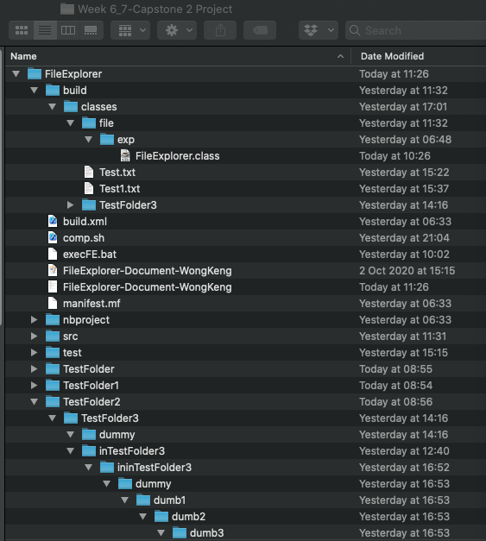

Directory Structure on my Mac

1. Compile and Run

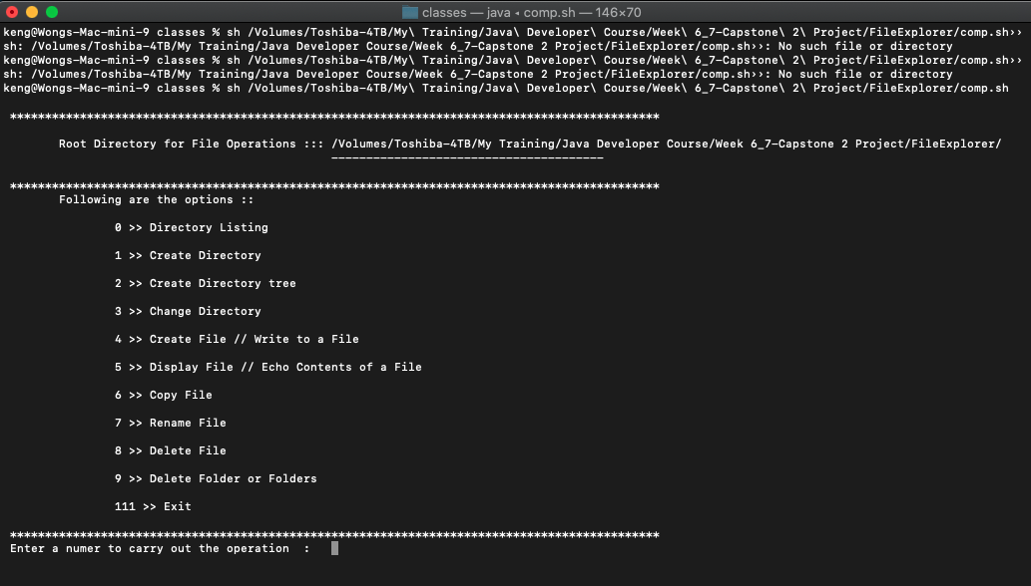

Application Menu

1. Create New Directory - createDir()
   * Current File Structure

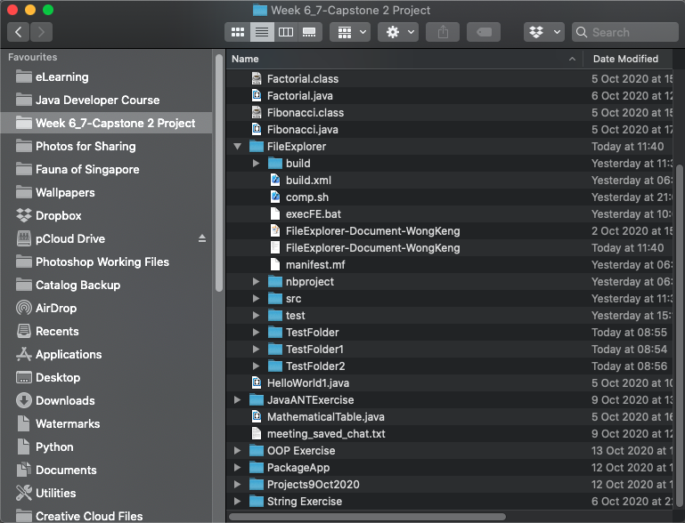

Current File Structure

* + After execution of createDir()

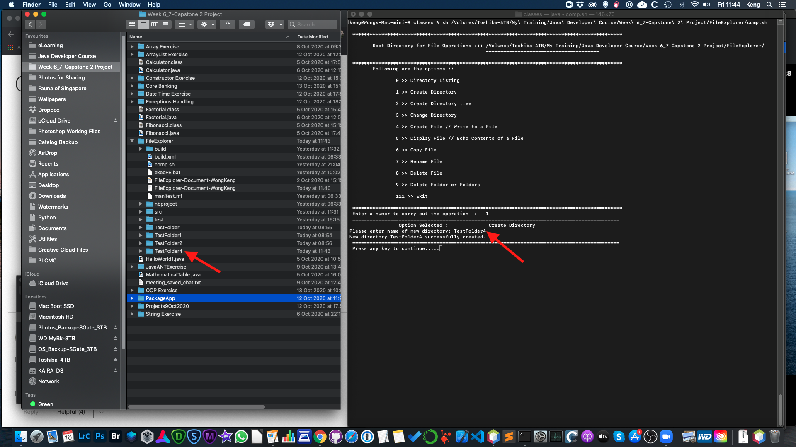

New directory, TestFolder4, created

1. After execution of createDirTree()

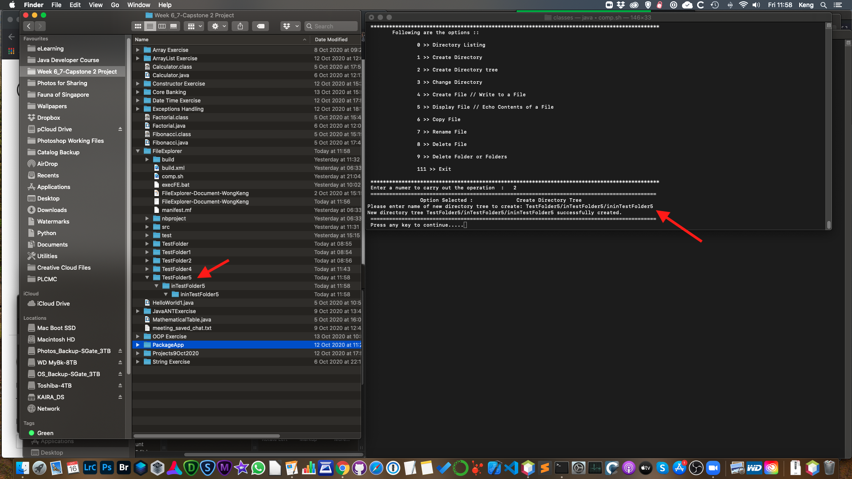

New directory tree, TestFolder5/inTestFolder5/ininTestFolder5 created

1. After execution of changeDir()

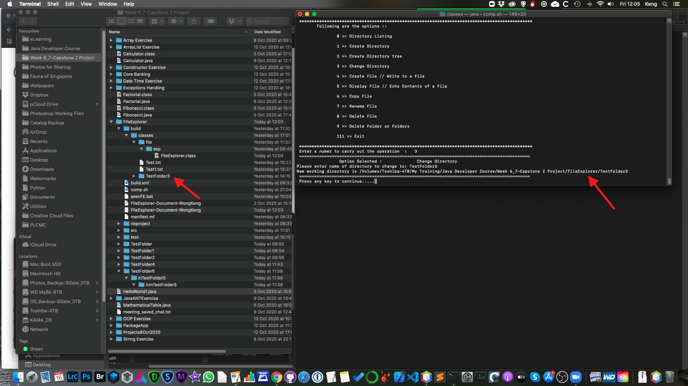

Change working directory to TestFolder3

1. After execution of createFile()

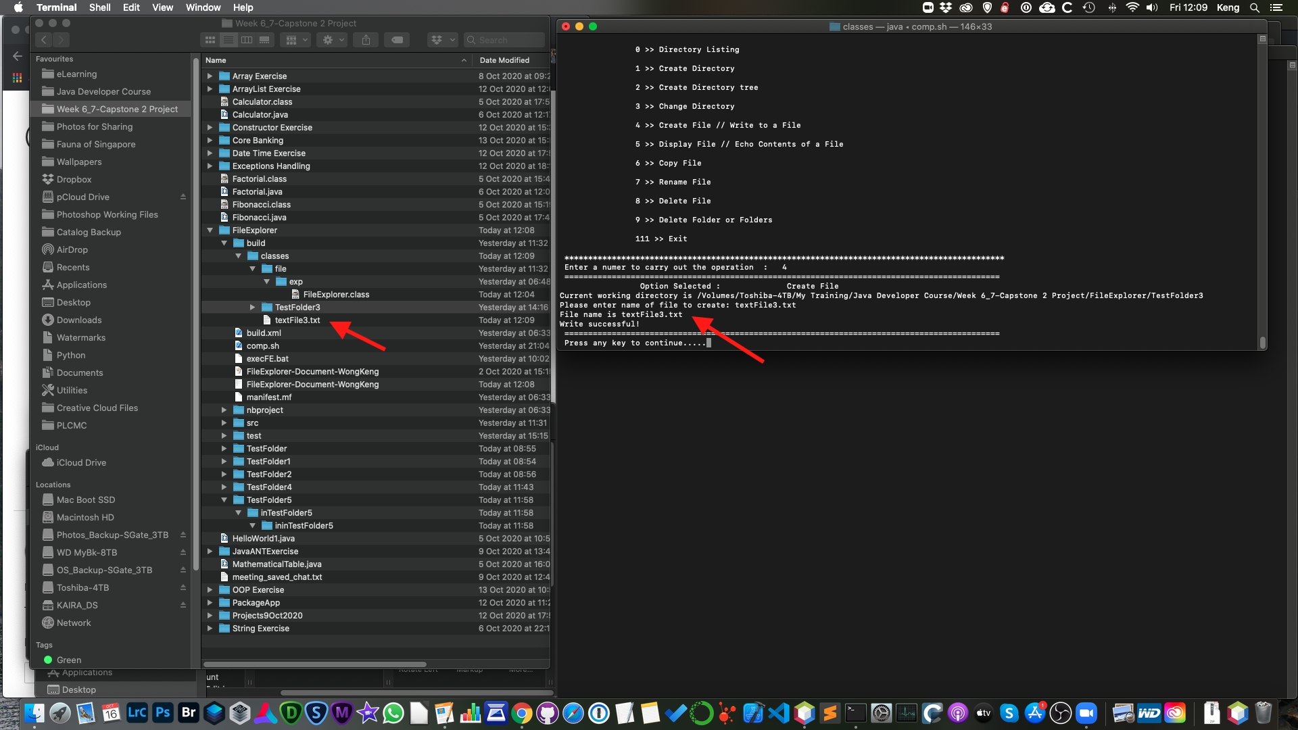

textFile3 created and written into

1. After execution of readFileContent()

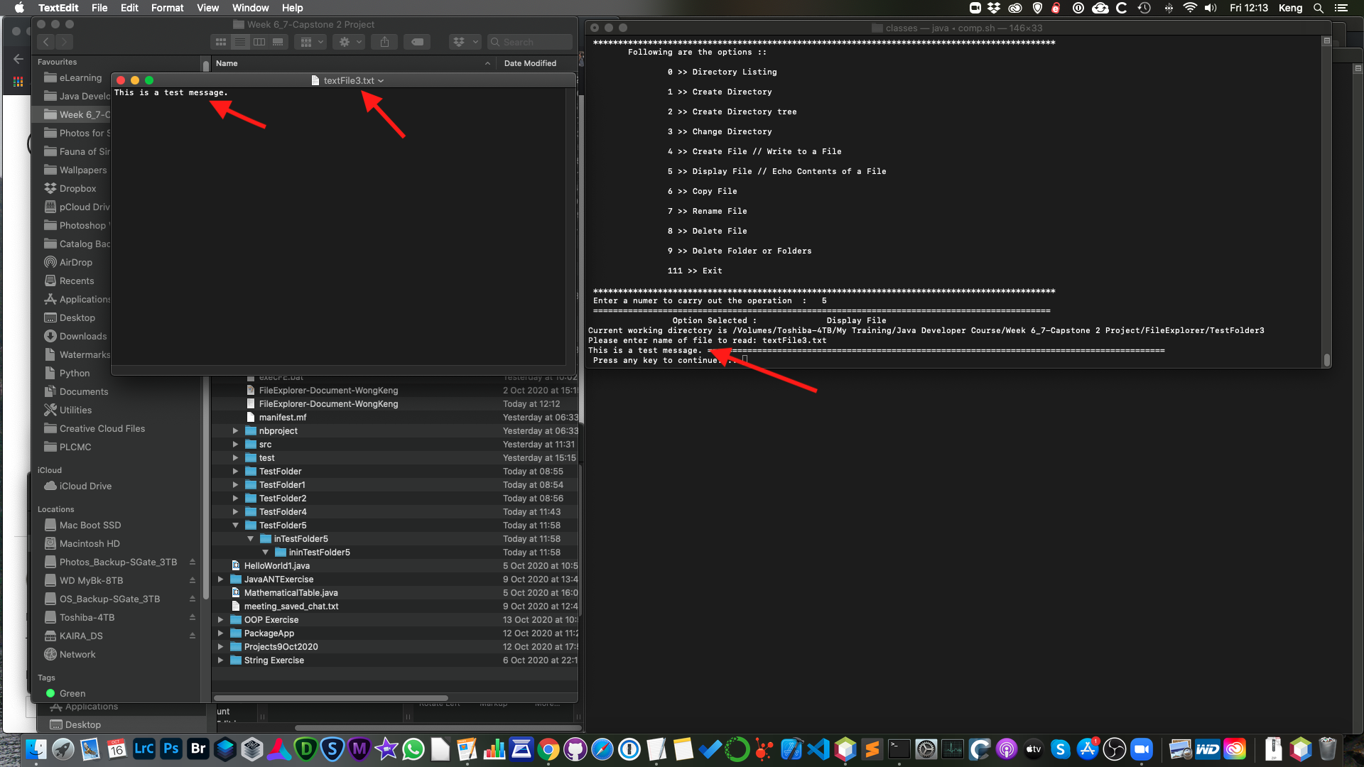

“This is a test message” displayed

1. After execution of copyFile()

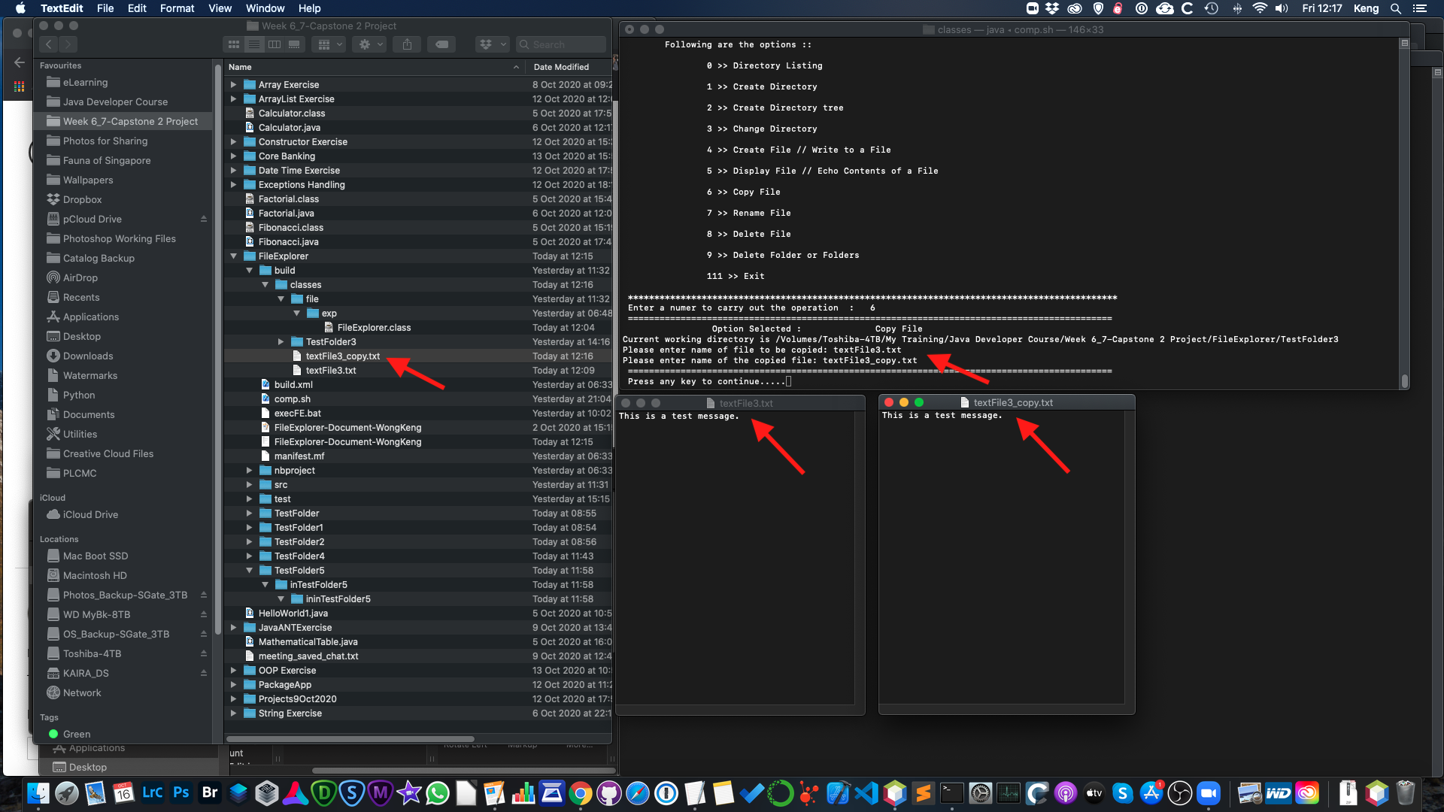

Copy of textFile3.txt - textFile3_copy.txt created

1. After execution of renameFile()

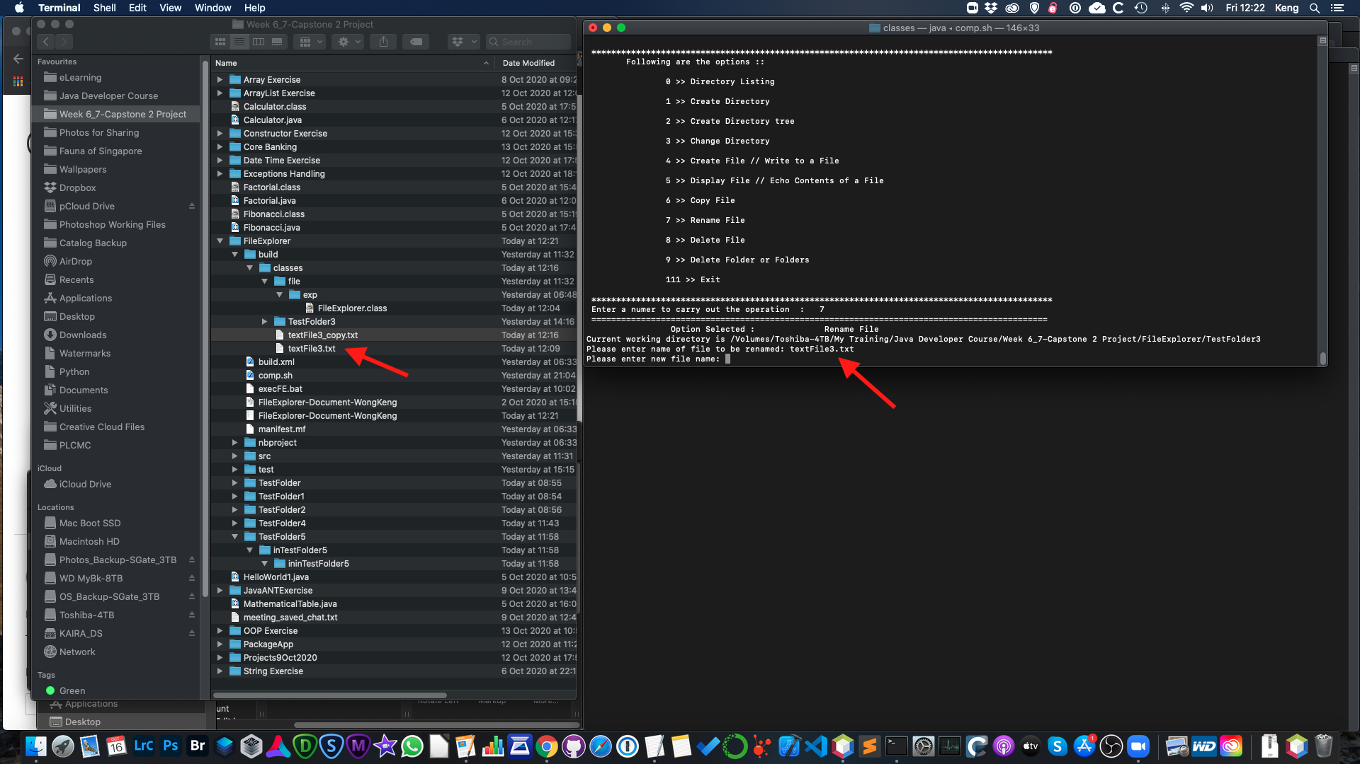

Before File Name change

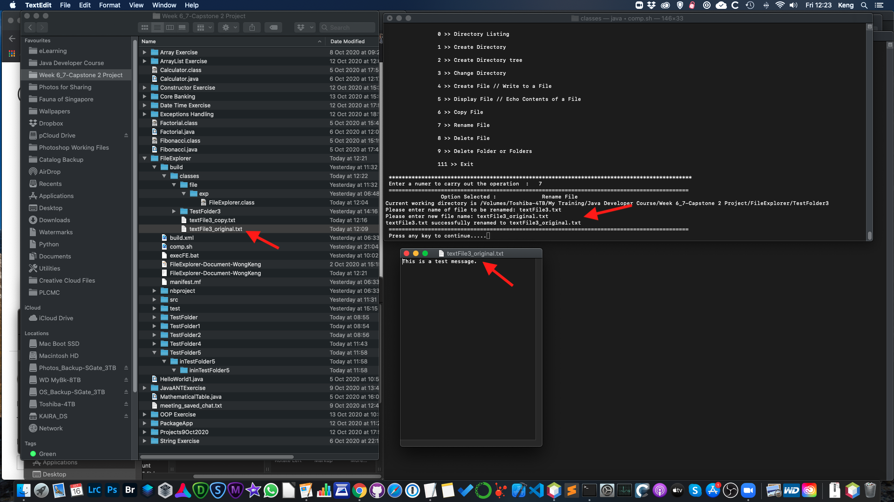

After File Name change

1. Execution of deleteFile()

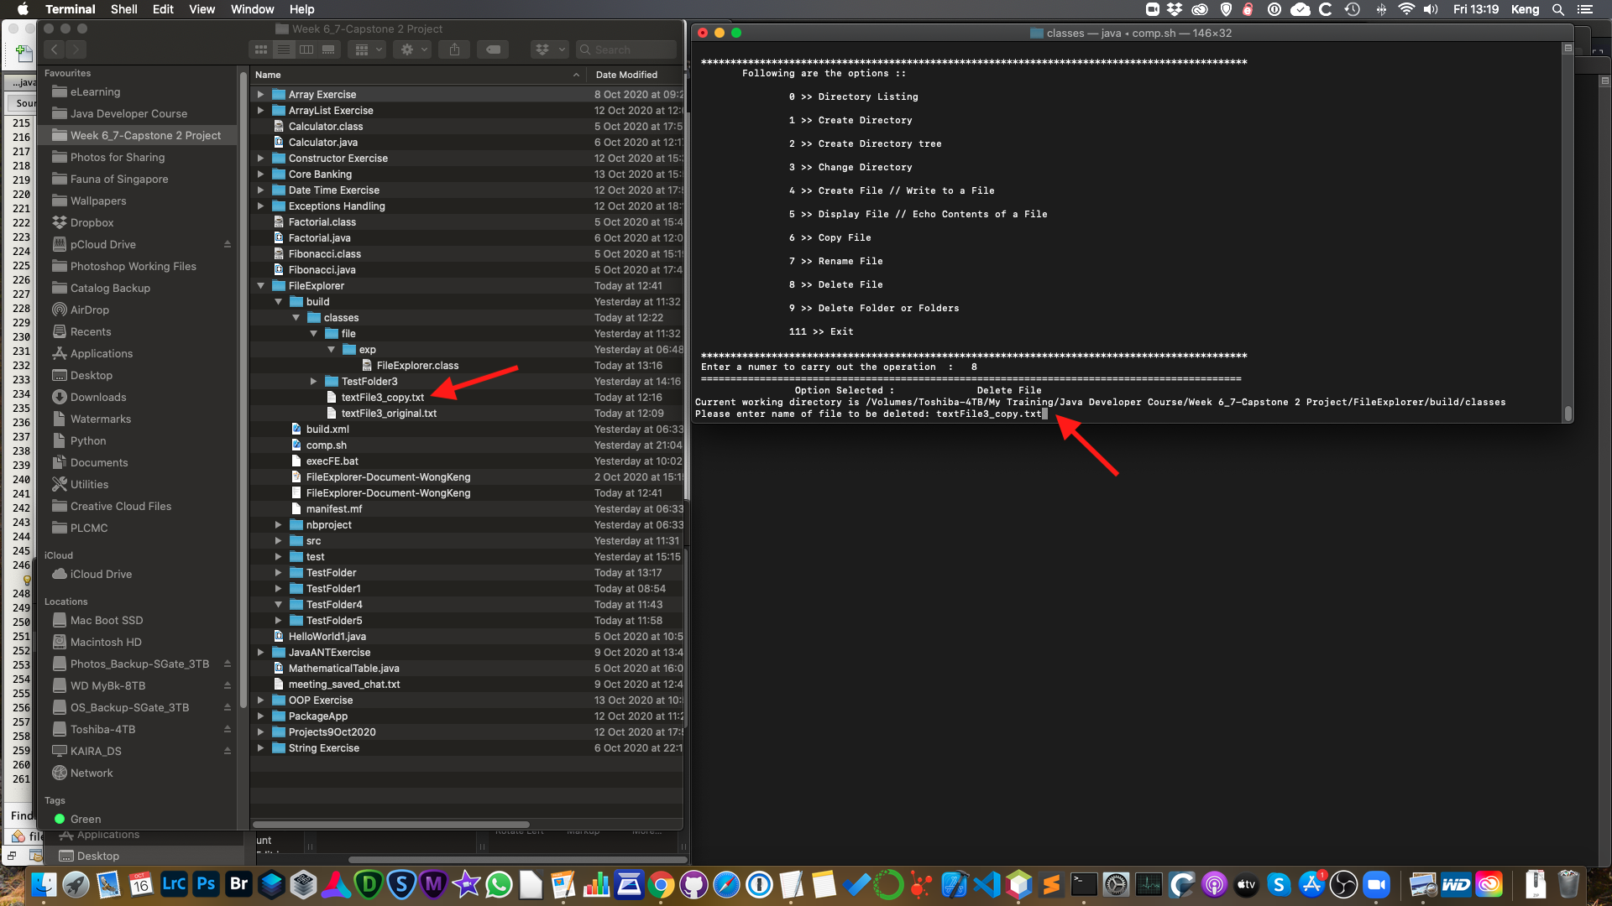

textFile3_copy.txt before execution of deleteFile()

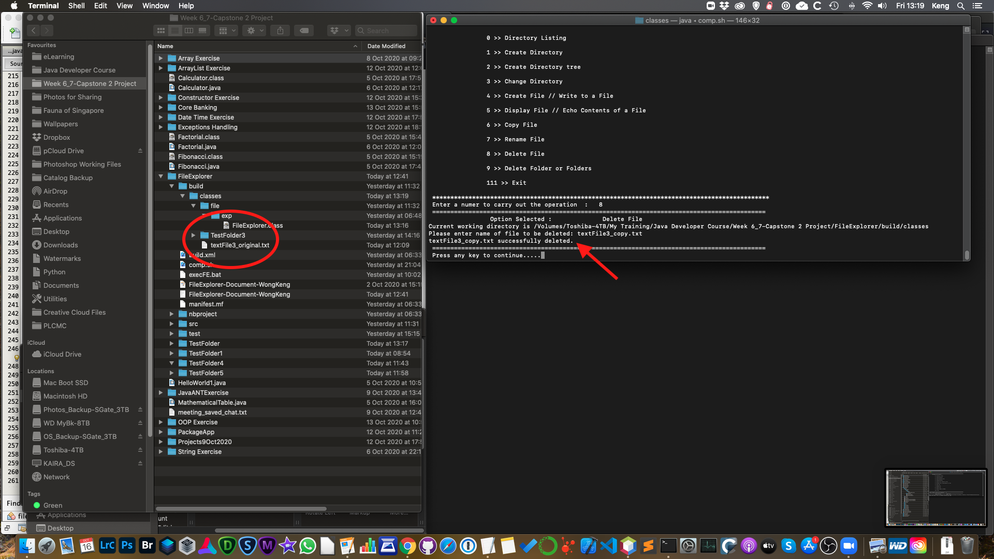

After execution of deleteFile()

1. Execution of deleteFolder(), deleteNotEmptyDir()

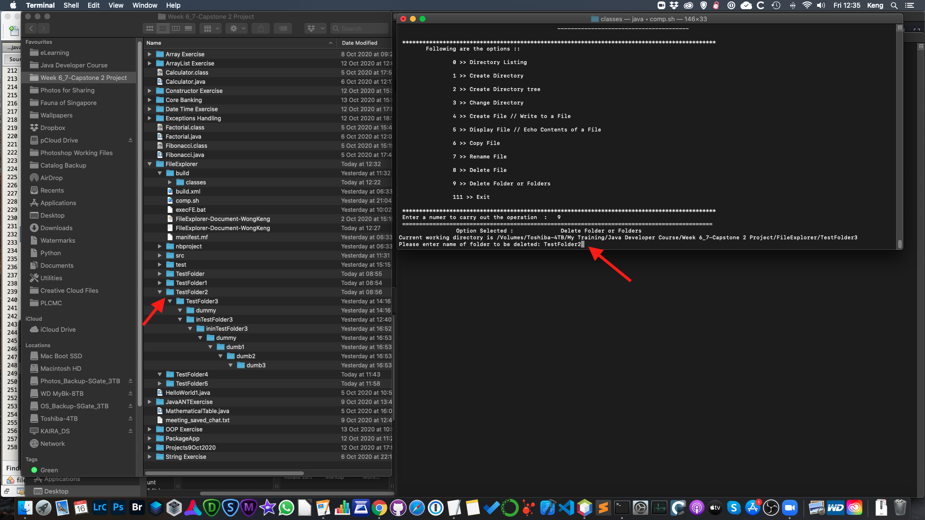

Before deleting folder, TestFolder2

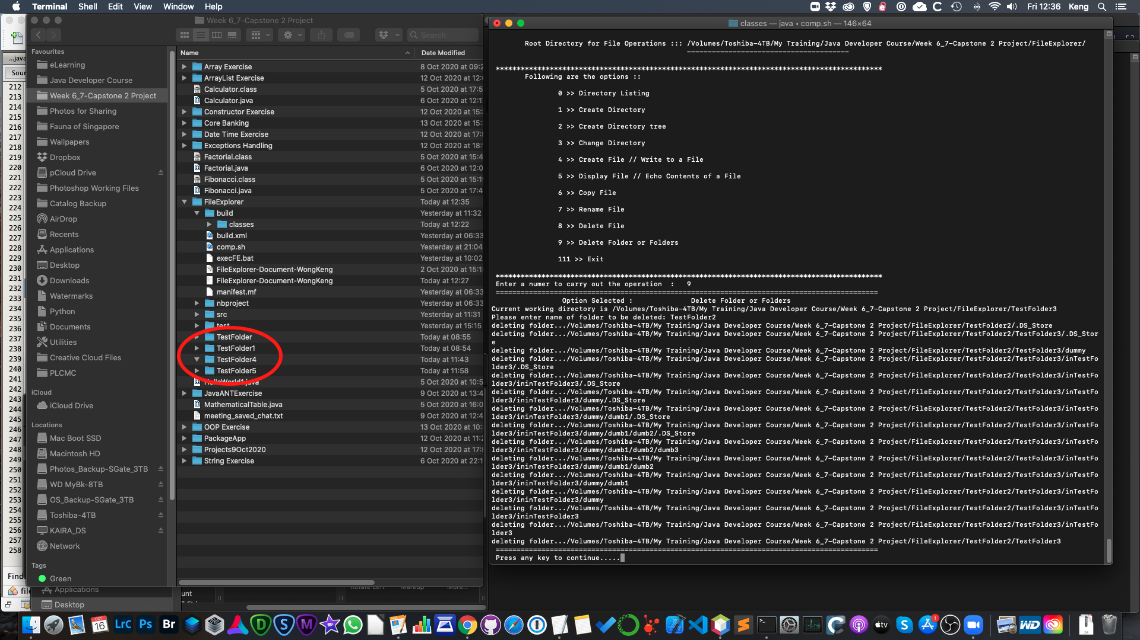

After execution of deleteFolder() and deleteNotEmptyDir()

1. **What did I learn:**

From this FileExplorer project, I learned the follow:

* How to make use of the various APIs in the File, FileWriter, FileInputStream and FileOutputStream classes.
* The working principle behind a recursive method call which I took quite a while to understand and then to implement it in the folder deletion method - deleteNotEmptyDir(). This is my most satisfying accomplishment in this FileExplorer project!
* Reading and writing from/to files using the various methods; synchronous (direct) and asynchronous (buffered) modes.